Standard Operating Procedure
Date Created | August 2017 | Version Number | 1.0
Created by | Melanie Colegrove | Owner | EP Team
Reviewed by | Julie Barlow, Pharmacy Clinical Services Manager | Time to Operate | 5-10mins
Checked by |  | Frequency of Use | Daily
Purpose of SOP | Procedure for amending a referral to community pharmacy via Meditech | SOP
Project / System | PharmOutcomes
Tools / Equipment | Meditech access | Next Review Date | August 2019

No | Main Operating Steps | Explanation / Examples / Diagrams
1 | From the Status Board identify and select the patient, ensuring you have the correct CC number | 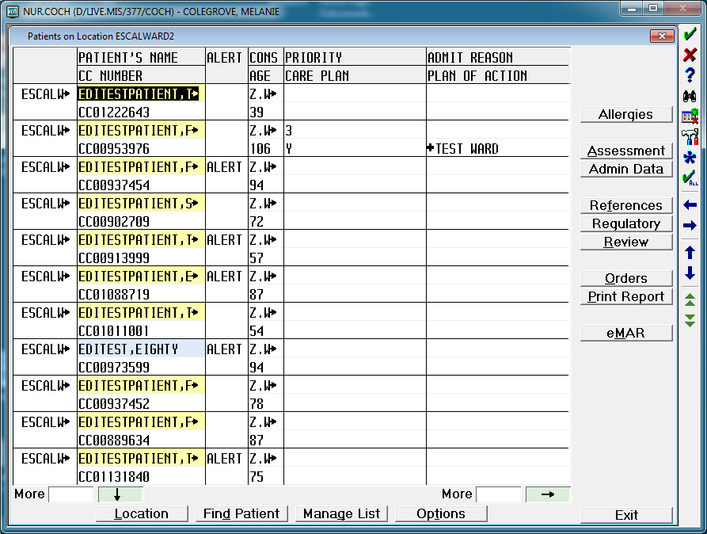
2 | Select Regulatory
 | Select ETTO Prescription Tracking
17 | In the “Dept/Cat” field type PHARMACY and press <Return> | 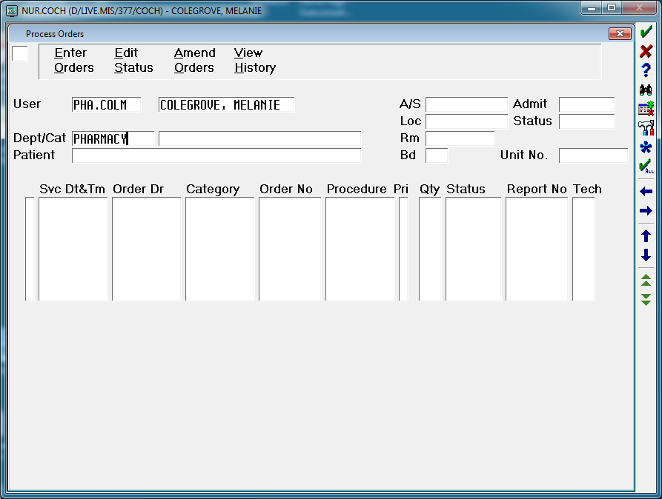
 | In the “Patient” field press <spacebar> followed by <Return> | 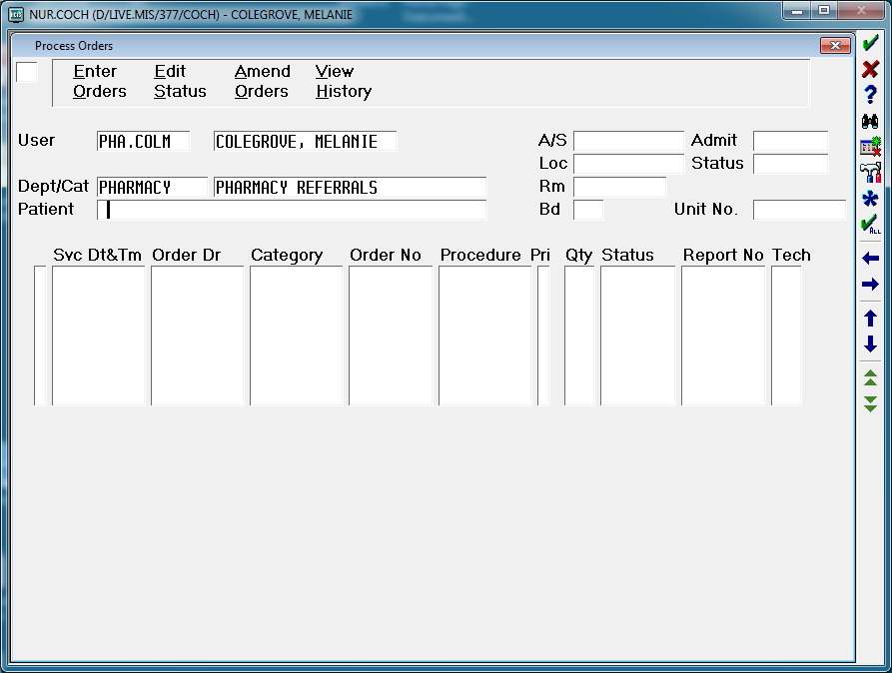
18 | At the Yes/No Confirmation prompt confirm it is the correct patient and select Yes if correct | 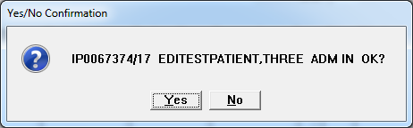
19 | Select the appropriate referral using the black bar to highlight it | 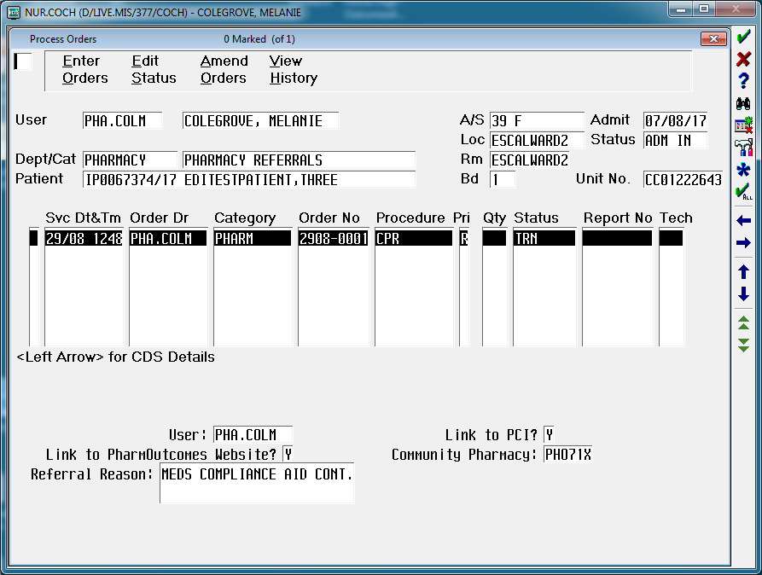
20 | In the field in the top left hand corner, type AO (i.e. Amend Order)  Press <Return> | 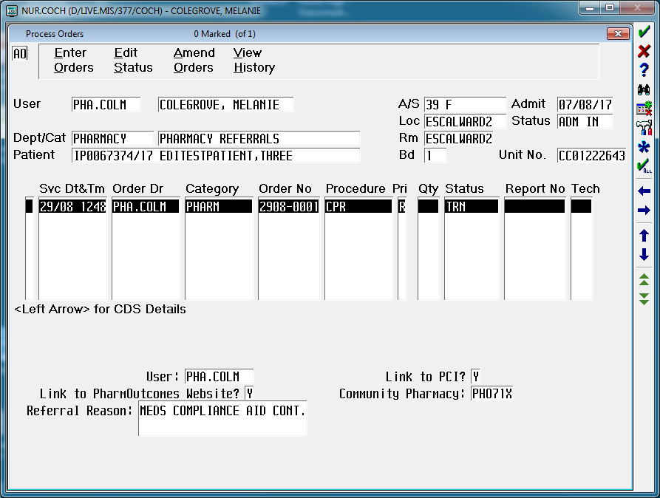
21 | Press <Return> until you reach the field(s) to be amended e.g.:  - Link to PharmOutcomes Website?  (to search for a different nominated Community Pharmacy and ODS code)  - Community Pharmacy  (to amend the ODS code)  - Referral Reason  - Additional Comments  Make the required amendments  *Note:  Refer to SOP “Procedure for entering a referral to community pharmacy via Meditech” for full details on how to complete these fields. | 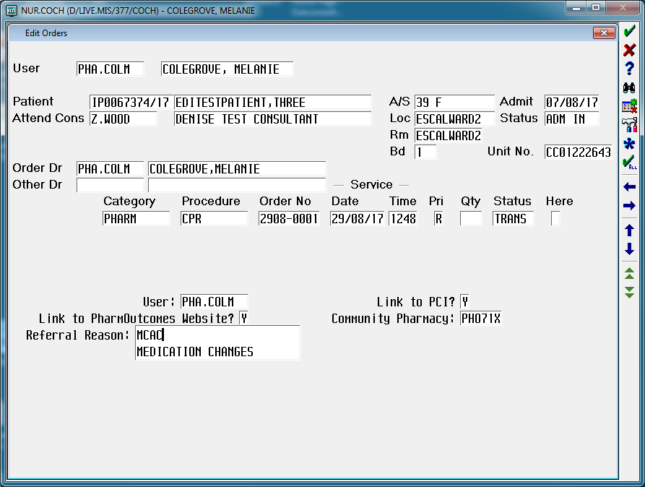
22 | Once all the amendments have been made  press <F12> to save the amendments | 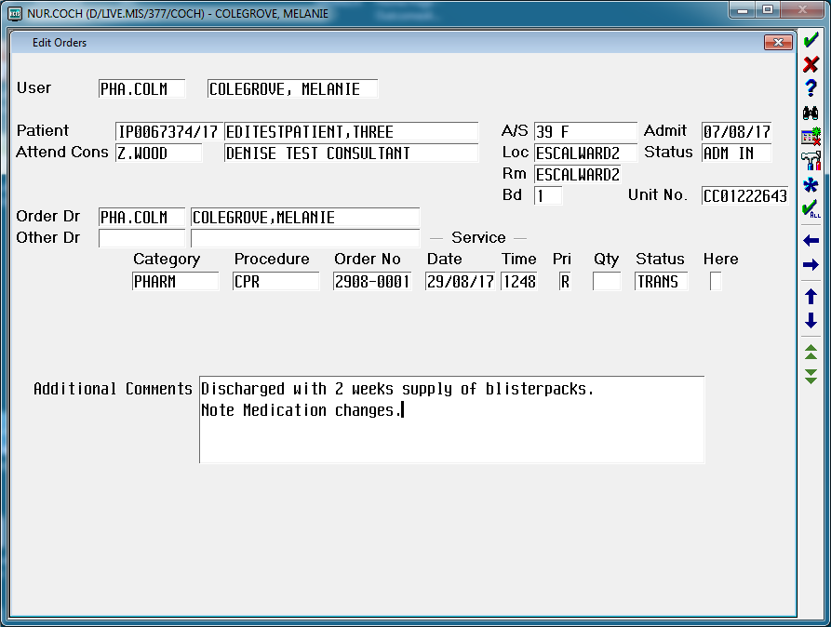
23 | At the “File Verified?” prompt select Yes | 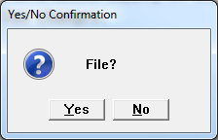
24 | End of Operation

