Standard Operating Procedure
Date Created | August 2017 | Version Number | 1.0
Created by | Melanie Colegrove | Owner | EP Team
Reviewed by | Julie Barlow, Pharmacy Clinical Services Manager | Time to Operate | 5-10mins
Checked by |  | Frequency of Use | Daily
Purpose of SOP | Procedure for cancelling a referral to community pharmacy via Meditech | SOP
Project / System | PharmOutcomes
Tools / Equipment | Meditech access | Next Review Date | August 2019

No | Main Operating Steps | Explanation / Examples / Diagrams
1 | From the Status Board identify and select the patient, ensuring you have the correct CC number | 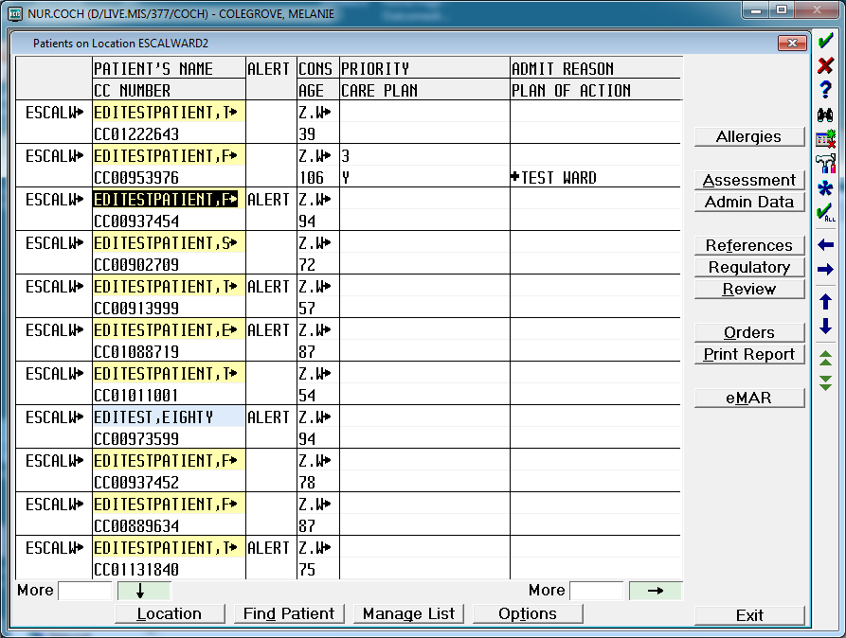
2 | Select Regulatory
 | Select ETTO Prescription Tracking
17 | In the “Dept/Cat” field type PHARMACY and press <Return> | 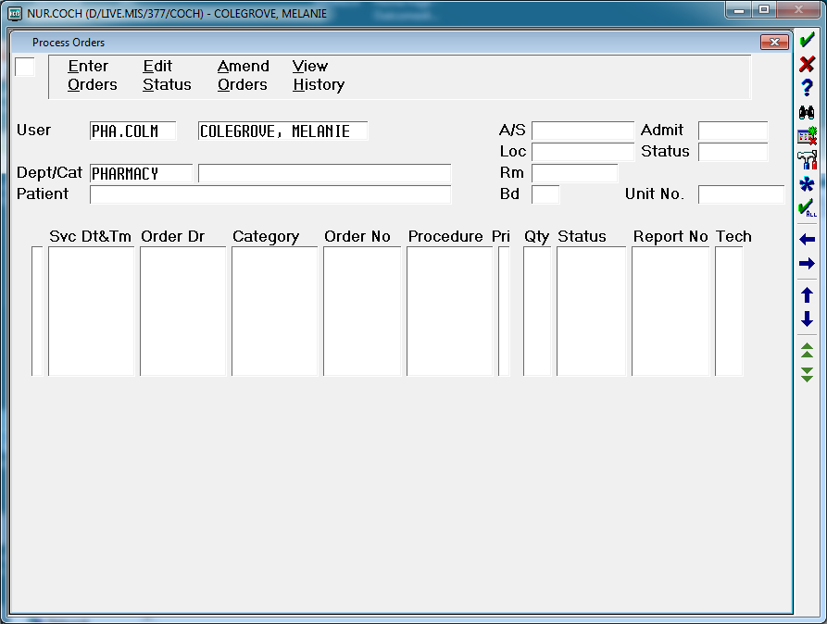
 | In the “Patient” field press <spacebar> followed by <Return> | 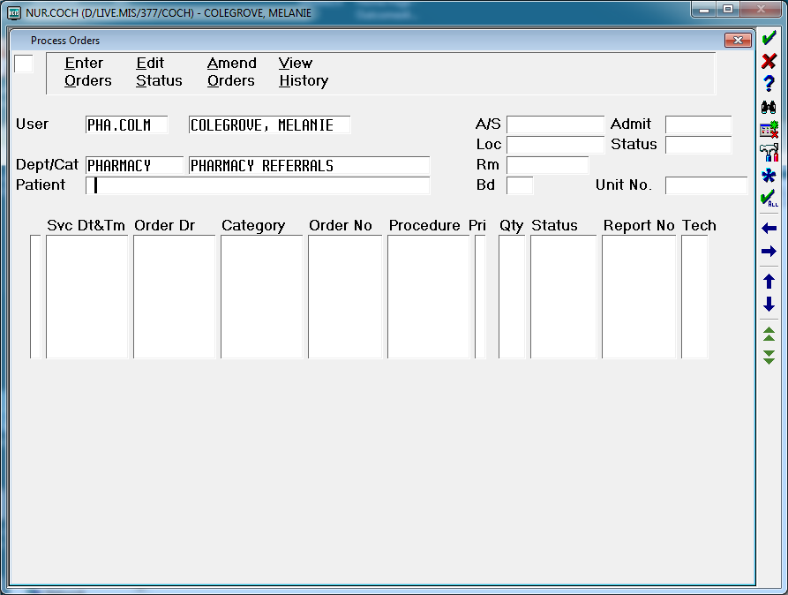
18 | At the Yes/No Confirmation prompt confirm it is the correct patient and select Yes if correct | 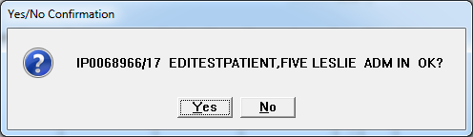
19 | Select the appropriate referral using the black bar to highlight it | 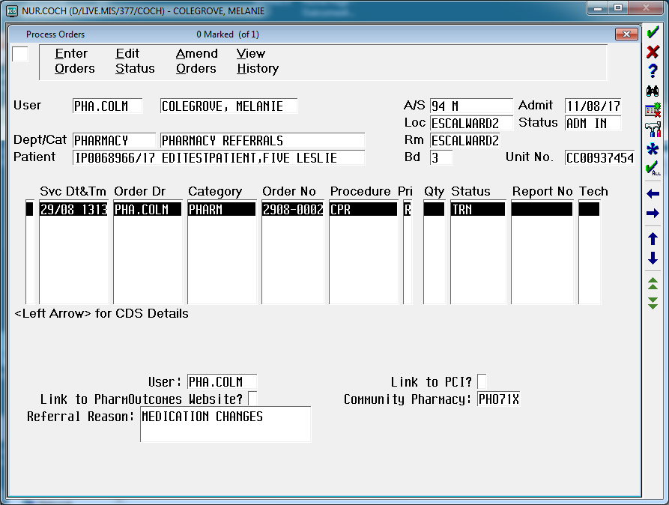
20 | In the field in the top left hand corner, type ES (i.e. Edit Status)  Press <Return> | 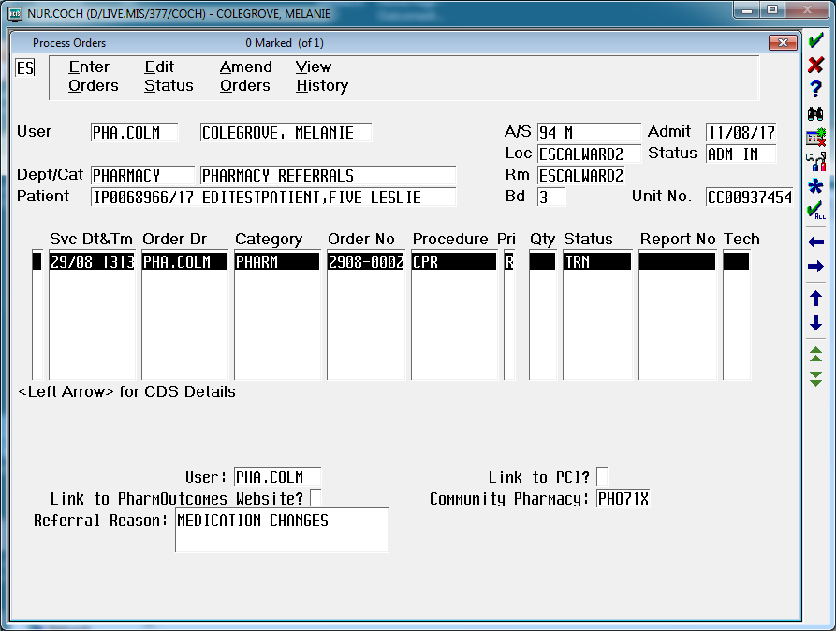
21 | Select a Status of X - Cancelled | 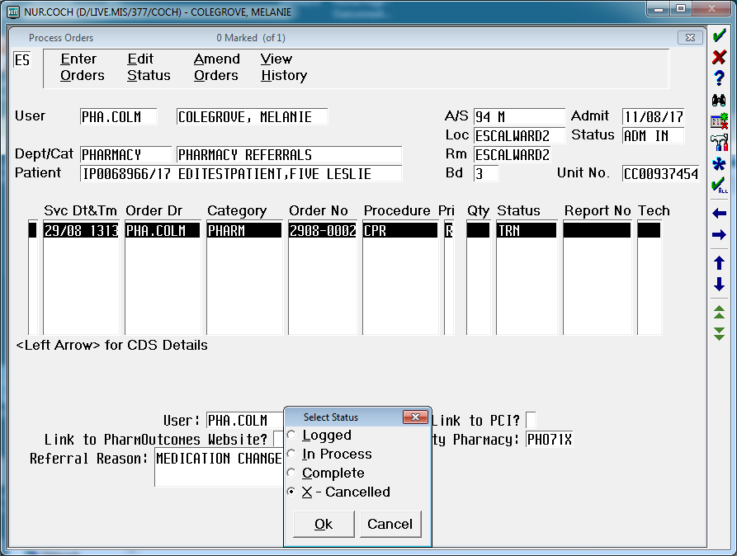
22 | Select Ok
23 | In the “Reason for Cancellation” field press <F9> to view the Cancellation Query Lookup list | 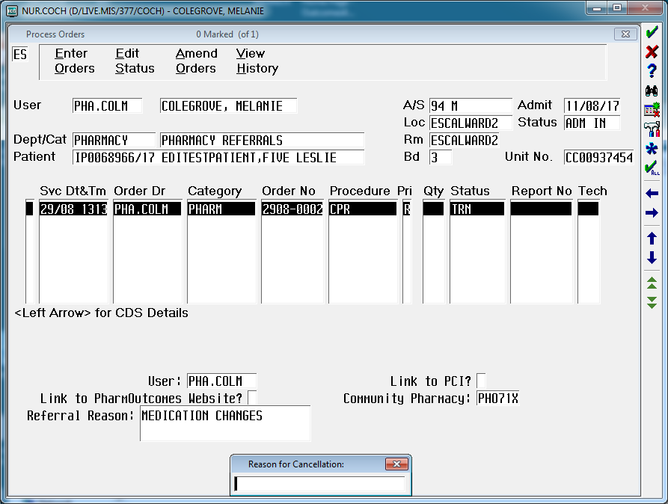
24 | Select the appropriate option and press <Return> | 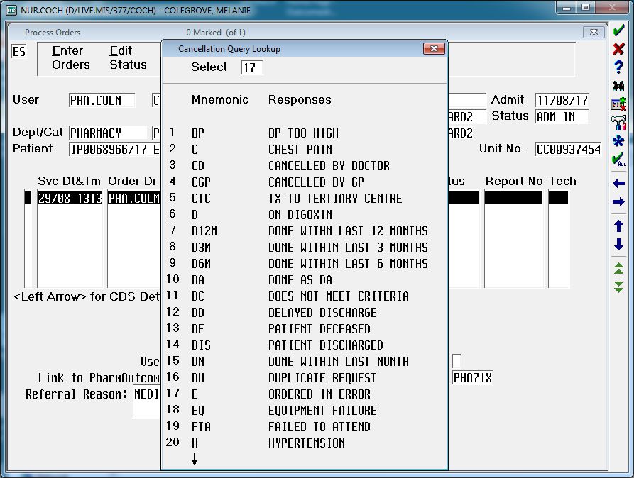
25 | The Status will have changed to CNC and the reason will be displayed. | 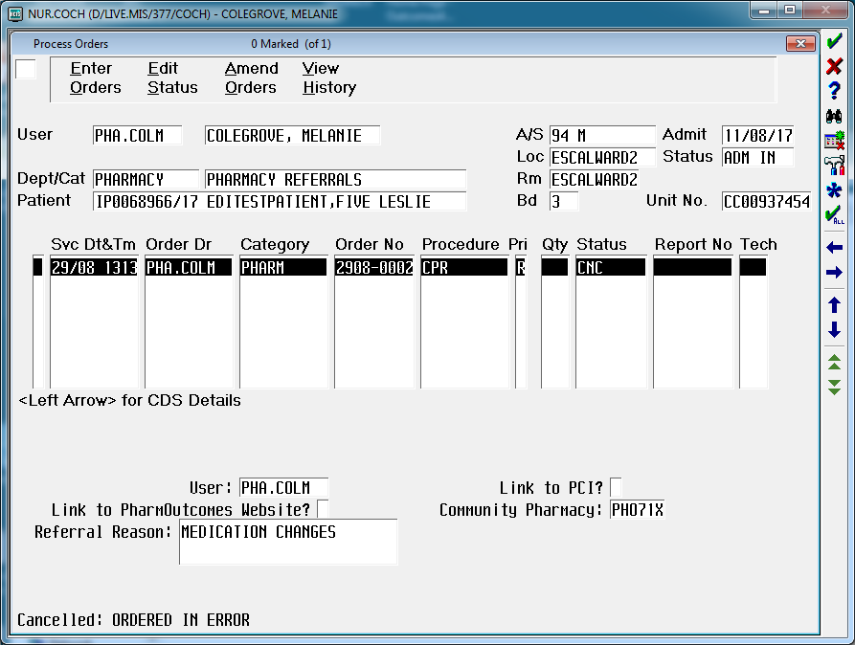
26 | End of Operation

