Standard Operating Procedure
Date Created | August 2017 | Version Number | 1.0
Created by | Melanie Colegrove | Owner | EP Team
Reviewed by | Julie Barlow, Pharmacy Clinical Services Manager | Time to Operate | 5-10mins
Checked by |  | Frequency of Use | Daily
Purpose of SOP | Procedure for entering a referral to community pharmacy via Meditech | SOP
Project / System | PharmOutcomes
Tools / Equipment | Meditech access | Next Review Date | August 2019

No | Main Operating Steps | Explanation / Examples / Diagrams
1 | From the Status Board identify and select the patient, ensuring you have the correct CC number | 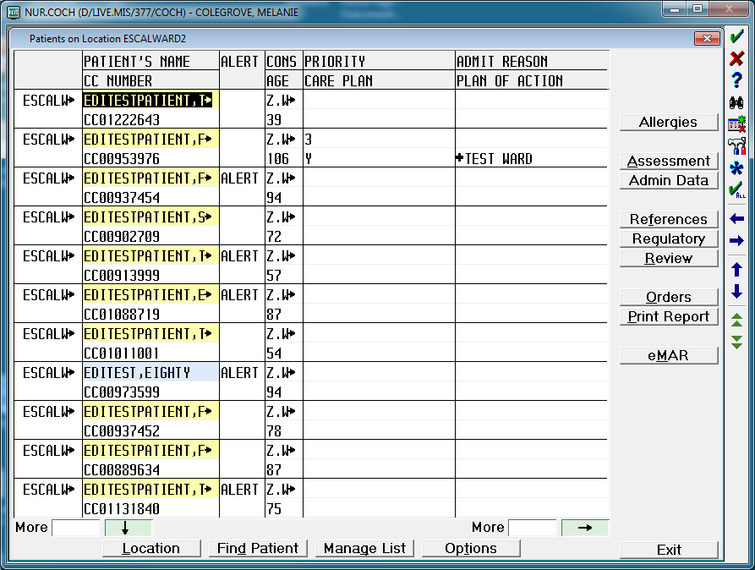
2 | Select Orders | 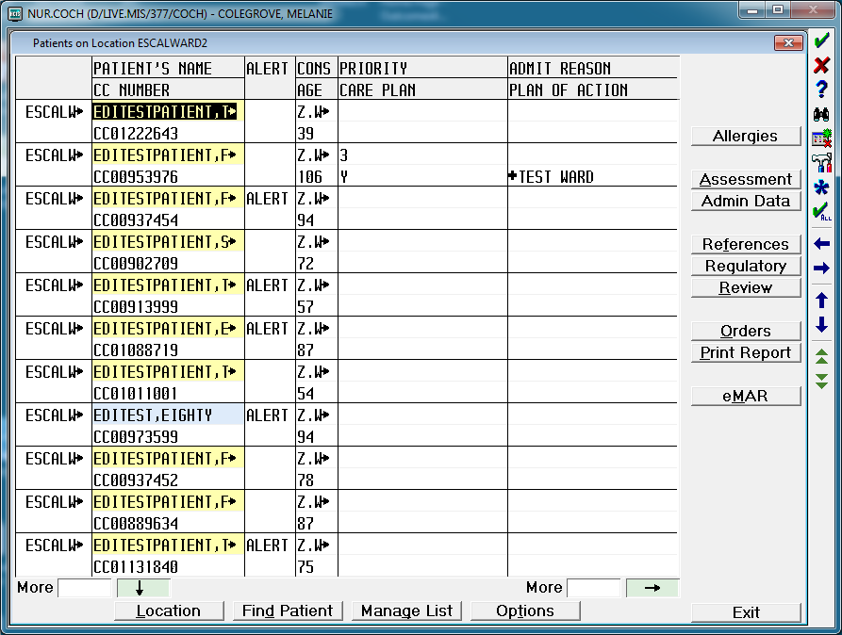
3 | In the “Category” field type PHARM and press <Return> | 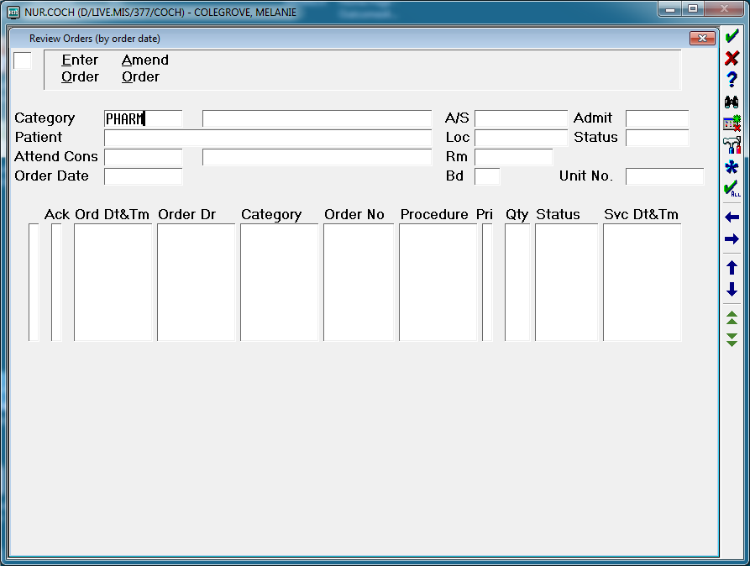
4 | The order screen will be populated with the patient details.  Confirm this is the correct patient.  Press <Return> | 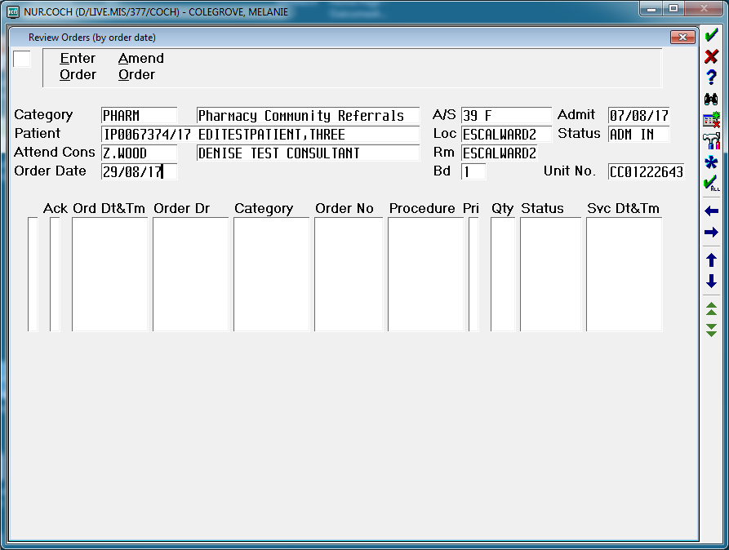
5 | In the field in the top left hand corner, type EO  (i.e. Enter Order)  Press <Return> | 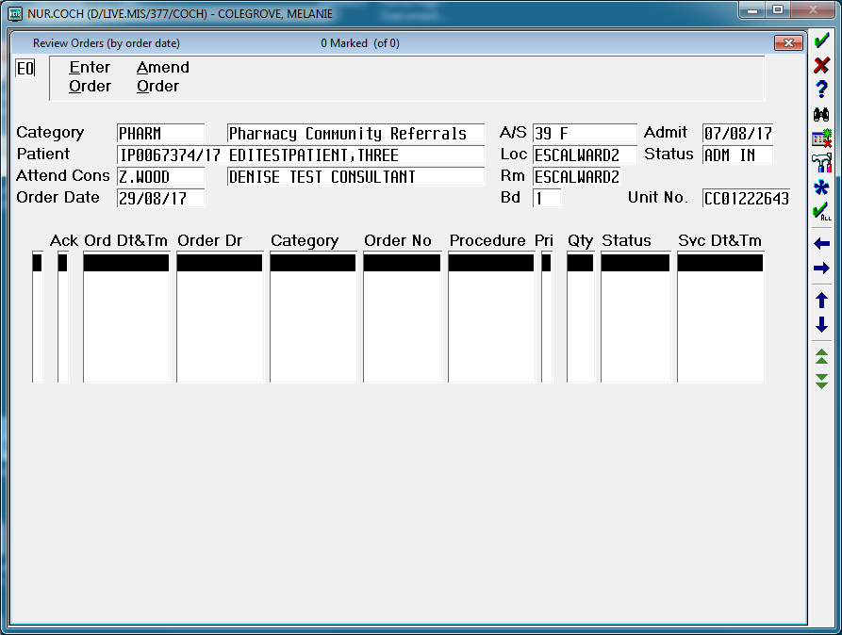
6 | Press <Return> until you reach the “Category” field | 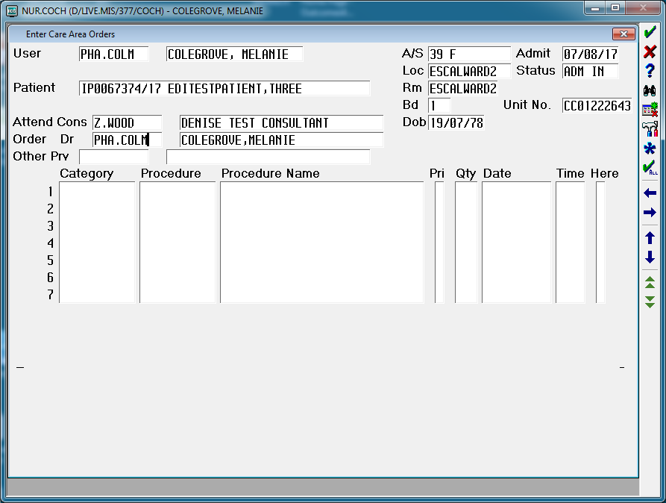
7 | In the “Category” field type PHARM and press <Return>  In the “Procedure” field type CPR (or select CPR from the <F9> look up menu)  Press <Return> | 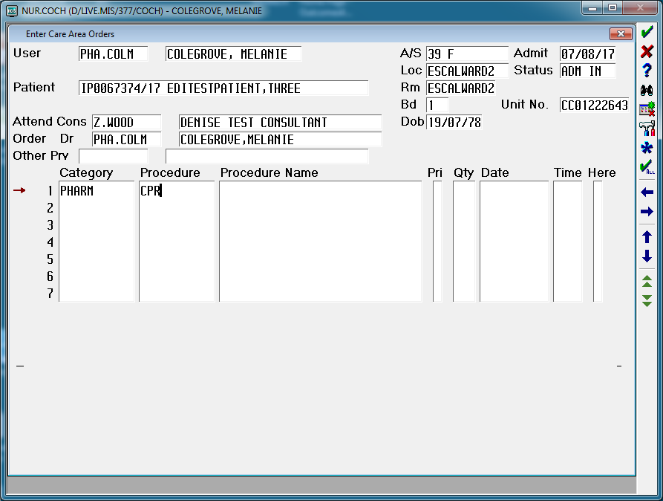
8 | The screen will be pre-populated with the following field data  “Pri” R and “Date” T+  In the “Pri” field accept the default of R by pressing <Return>  In the “Date” field delete + and press <Return>  In the “Time” field type N and press <Return> | 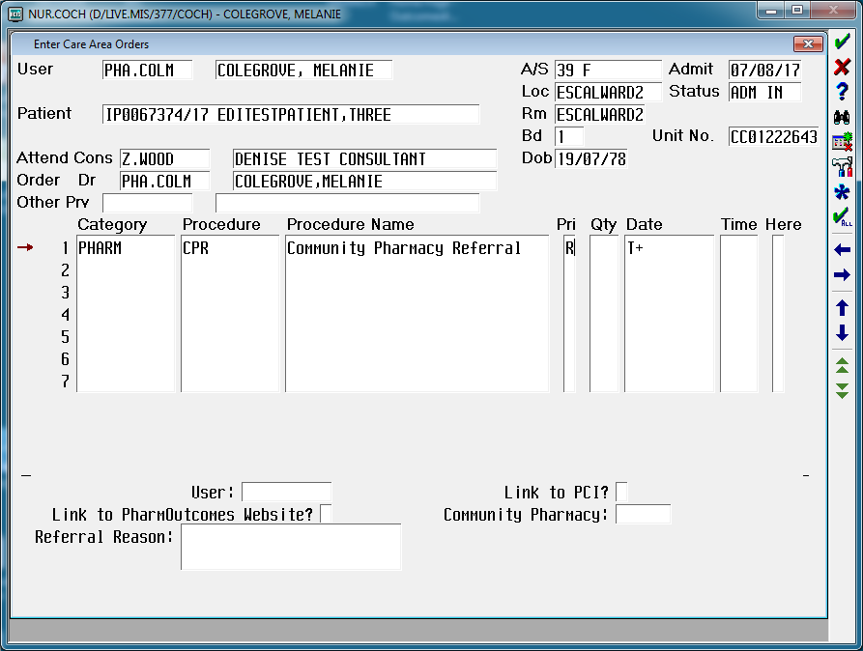  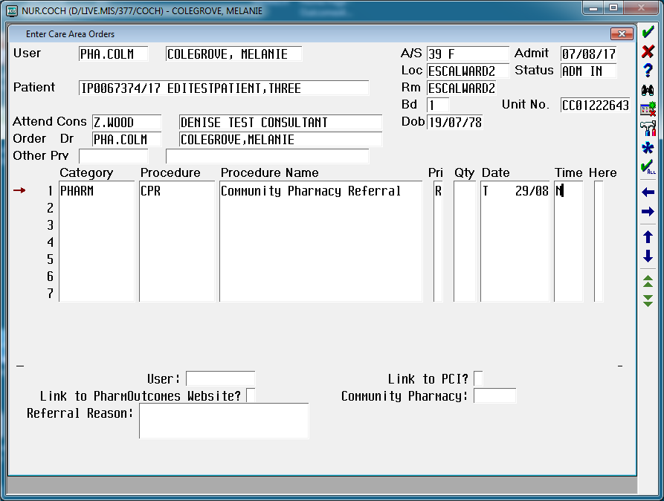
9 | The “User” field with be automatically populated with your Meditech user Mnemonic  Press <Return> | 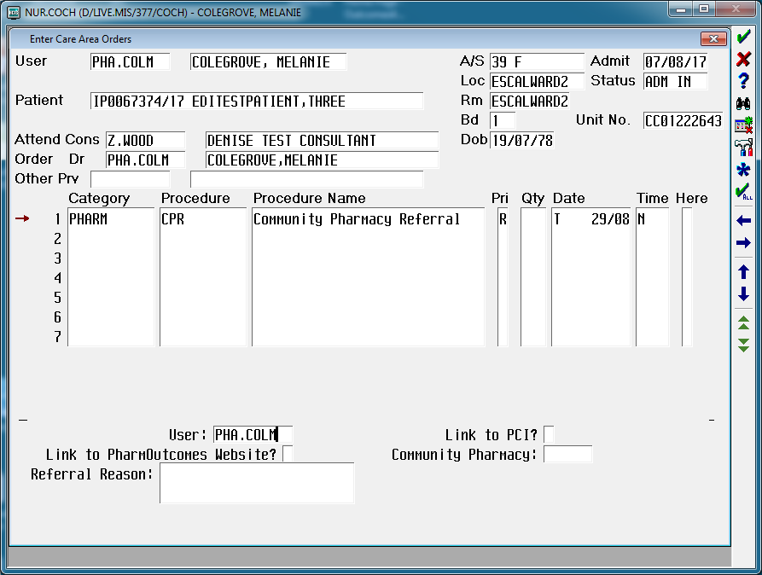
10 | If you need to access PCI at this stage, type Y in the “Link to PCI?” field.  This will link to the PCI screen  (Note: to exit from the PCI screen press <F11> and select YES at the “Exit PCI?” prompt)  If you do not want to access PCI, leave this field blank  Press <Return> | 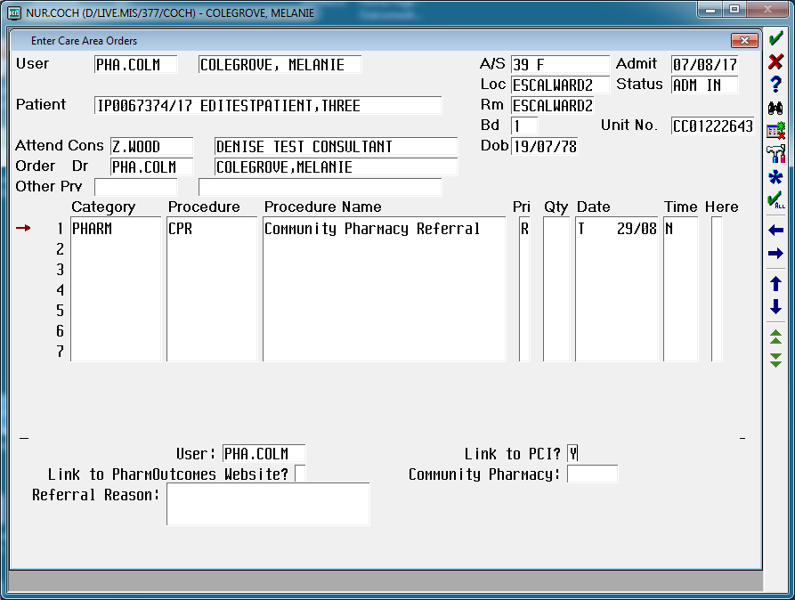
11 | To search for the patient’s nominated Community Pharmacy access the PharmOutcomes Website via the link provided.  In the “Link to PharmOutcomes Website?” field type Y and press <Return> | 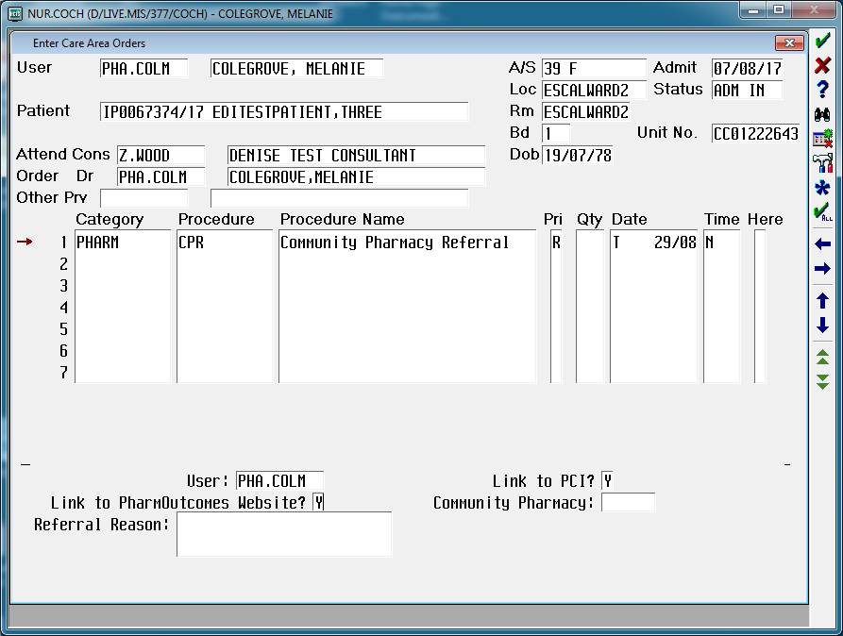
12 | This opens up the PharmOutcomes Referral Provider Search web page.  Search for the patient’s nominated Community Pharmacy using the “Provider Search” box on the website.  You can search by typing different search terms in the search box e.g.:  - pharmacy name  - postcode  - street name  - area (e.g. Blacon, Upton)  A drop down list of matching Community Pharmacy options will be displayed. | 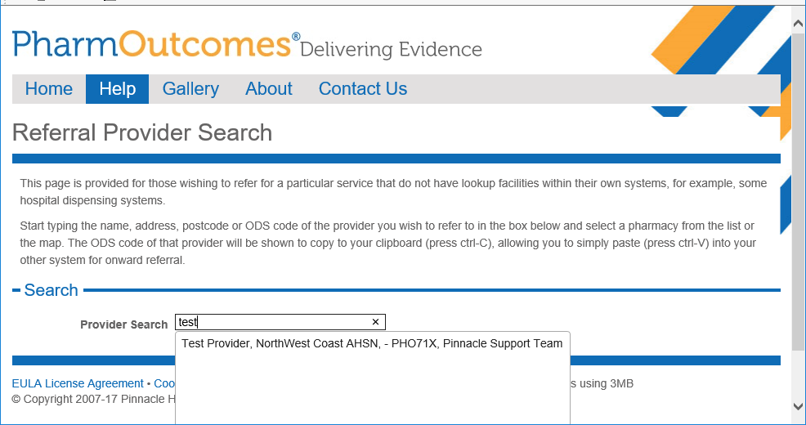
13 | Select the required Community Pharmacy from the drop down list by clicking on it with the mouse.
14 | The Provider ODS Code for the selected pharmacy will then be displayed.  Copy this code using Ctrl-C  Move back to the Meditech Order screen | 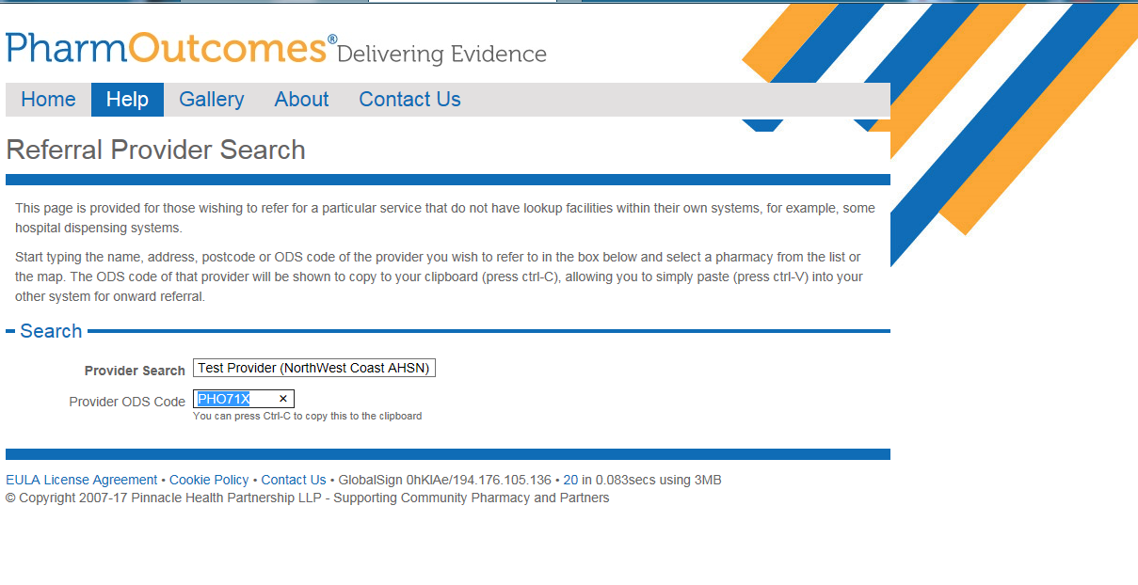
15 | Place the cursor in the “Community Pharmacy” field  Use Alt-V to paste the code into that field  Press <Return> to continue completing the whole referral*  *Note:  If you are entering this on admission, to ensure an admission notification is sent automatically to the nominated Community Pharmacy, the rest of the referral doesn’t need to be completed at this stage.  Press <F12>  At the “File Verified?” prompt select Yes  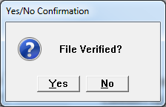 | 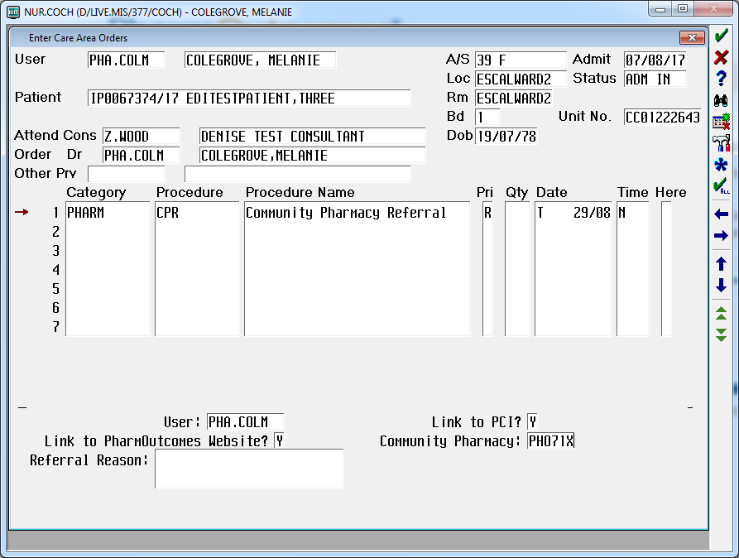
16 | In the “Referral Reason” field press <F9> to view the list of Referral Reasons  Select the appropriate reason and press <Return>  Note:  Multiple reasons can be entered here if appropriate | 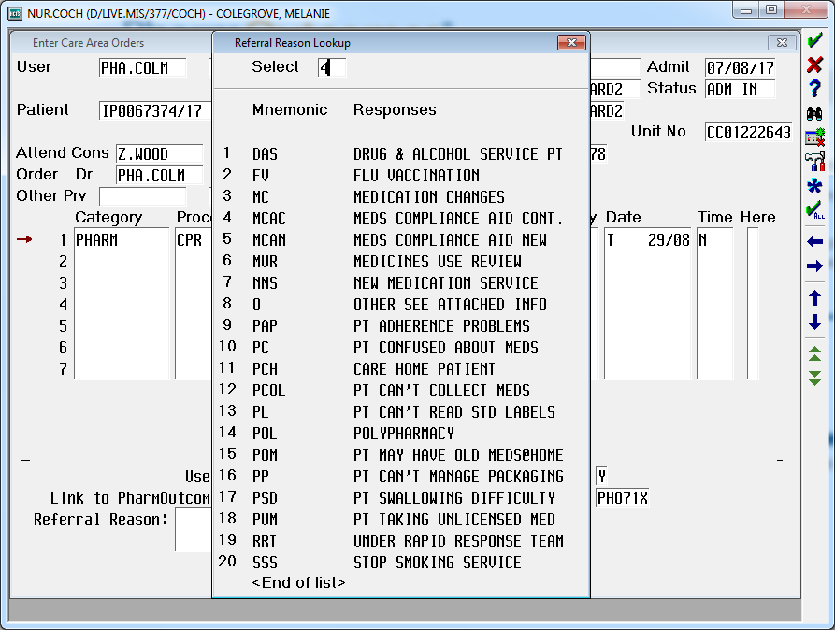
17 | Referral Reason field will be populated.  Press <Return> | 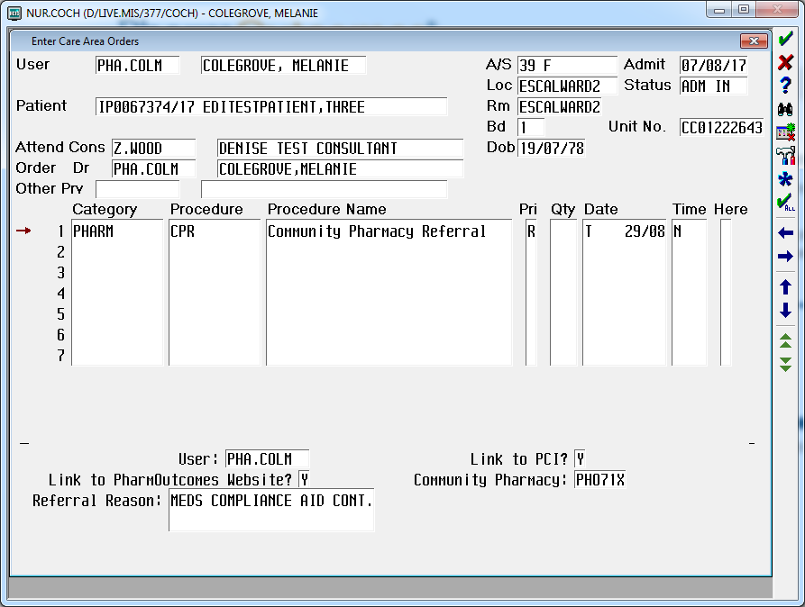
18 | In the “Additional Comments” field enter any other relevant information to be communicated.  This is a free-type field.  Press <F12> twice to File | 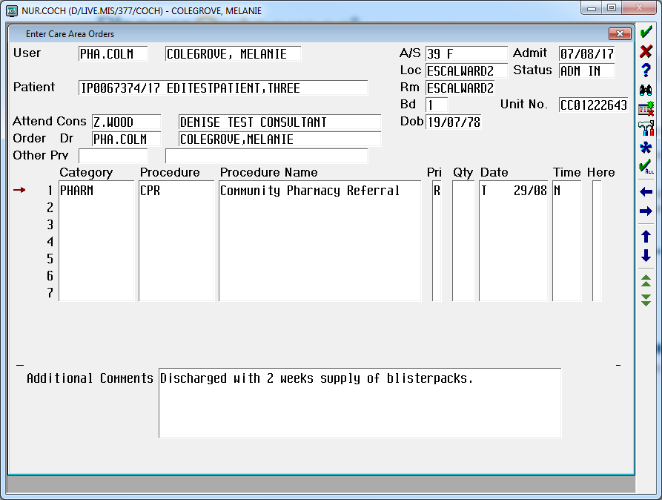
19 | At the “File Verified?” prompt select Yes
20 | The completed referral will look like this | 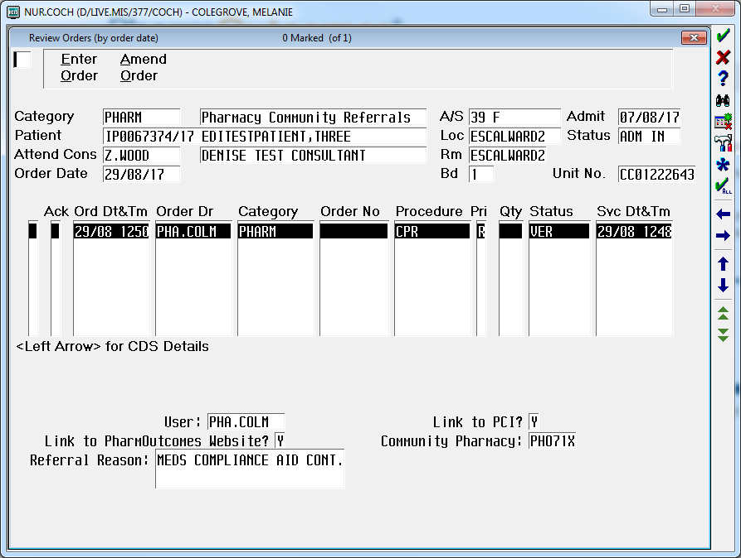
21 | End of Operation

